
RAMAIAH
Institute of Technology
USN | 1 | M | S

(Autonomous Institute, Affiliated to VTU)
(Approved by AICTE, New Delhi & Govt. of Karnataka) Accredited by NBA & NAAC with ‘A’ Grade

SEMESTER END EXAMINATIONS JANUARY – FEBRUARY 2021
Program | : | B.E. : Electrical and Electronics Engineering | Semester | : | VII
Course Name | : | Power Systems - II | Max. Marks | : | 100
Course Code | : | EE72 | Duration | : | 3 Hrs

Instructions to the Candidates:
- Answer one full question from each unit.
- Suitably assume any missing data.

 |  | UNIT- I
1. | a) | Define the following terms with examples:  - Tree and co-tree ii) Basic cut-sets. | CO1 | (04)
 | b) | For the system shown in fig. 1(b), construct by singular transformation method. The parameters of various elements are given in the table. Take node-6 as reference node.  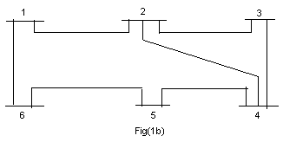 | CO1 | (08)
  Element  Number | Bus-code | Reactance in P.U
  1 | 1 - 2 | 0.04
  2 | 1 - 6 | 0.02
  3 | 2 - 4 | 0.03
  4 | 2 - 3 | 0.02
  5 | 3 - 4 | 0.08
  6 | 4 - 5 | 0.06
  7 | 5 - 6 | 0.05
 | c) | Form for the system shown in the fig. 1(c), by adding the elements in the sequence 1- 2, 1-3, 1- 4, 4-6, 2-5. Select node – 1 as the reference node. The line per unit reactance values are as indicated on the diagram.  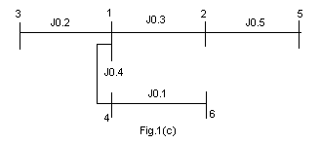 | CO1 | (08)
2. | a) | Explain primitive network in impedance form and admittance form. | CO1 | (04)
 | b) | Analyze and develop an expression for the step-by-step algorithm for the formation of bus impedance matrix when a branch is added to the partial network. | CO1 | (08)
 | c) | 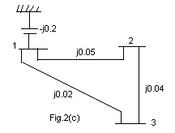  For the power system shown in fig.2(c), obtain using singular transformation. Verify the obtained by inspection method. | CO1 | (08)
 |  | UNIT – II
3. | a) | Explain the following with respect to load flow analysis:  - Types of buses  - Constraints on load flow solutions. | CO2 | (08)
 | b) | Fig. 3(b) shows a 3 bus power system. Using Gauss-Seidal method, determine the bus voltage at the end of first iteration. The transmission line values are impedances in PU. The bus data is given as follows:  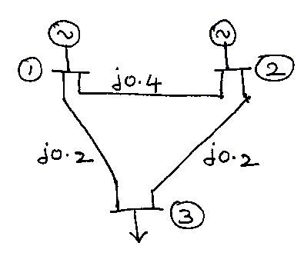  Fig. 3(b) | CO2 | (08)
  Bus | Generation |  | Load |  | Voltage | Bus Type
  Bus | P_{G} (PU) | Q_{G} (pu) | P_{D} (PU) | Q_{D} (pu) | Voltage | Bus Type
  1 | - | - | - | - | 1.05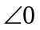 | Slack
  2 | 3 | - | - | - | 1.0 | PV
  3 | - | - | 4 | 2 | - | PQ
 | c) | For a given 14 bus power system with bus 1 as slack bus, buses 2 to 11 are PQ buses and buses 12 to 14 are PV buses, determine the dimension of the Jacobian matrix in the NR method of power flow solution. If in this system, if buses 12 to 14 are changed to PQ buses, determine the new order of the Jacobian matrix. | CO2 | (04)
4. | a) | From the fundamentals derive the static power flow equations. | CO2 | (06)
 | b) | What are the assumptions made in fast decoupled power flow method? Explain the algorithm briefly through a flow chart. | CO2 | (08)
 | c) | What are the data required for the power flow analysis? | CO2 | (06)
 |  | UNIT – III
5. | a) | Neglecting transmission losses, drive equal incremental cost criterion for economic generation scheduling in a interconnected system. | CO3 | (06)
 | b) | What are B co-efficients? Obtain the general loss co-efficient formula with usual notations. | CO3 | (08)
 | c) | A 2 bus system is shown in the fig. 5(c). If 100MW is transmitted from plant-2 to load bus-1 a transmission loss of 10MW takes place. Find the required generation for each plant and power received by the load, when the Lagrangian multiplier λfor the system is Rs.25/MWh. The incremental fuel cost are:  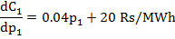  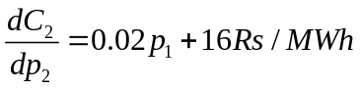  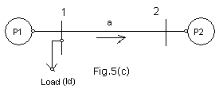 | CO3 | (06)
6. | a) | Explain the method of equal incremental costs for the economic operation of generators with the transmission loss considered. | CO3 | (06)
 | b) | The fuel inputs per hour of plant-1 and 2 are given as:  Determine the economic operating schedule and the cost of generation if the maximum and minimum loading on each unit is 100MW and 25MW, the demand is 180MW and transmission losses are neglected. If the load is equally shared by both units, determine the saving obtained by loading the units as per equal incremental production cost. | CO3 | (06)
 | c) | For a system one line diagram as shown in the fig. 6(c), assume, . If the voltage at bus3 .Find loss coefficients and power loss. Take , and  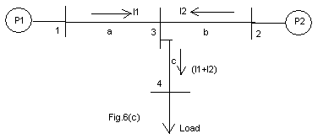 | CO3 | (08)
 |  | UNIT – IV
7. | a) | Discuss with relevant figures, the point by point method for solving swing equation under: i) pre fault, ii) post fault and iii) during fault condition. | CO4 | (10)
 | b) | Illustrate clearly the steps involved in solving swing equation using Runge-Kutta method for transient analysis. | CO4 | (10)
8. | a) | Explain the modified Euler’s method used in the solution of swing equation under transient stability studies. | CO4 | (10)
 | b) | For the swing equation, 0.0331d²δ/dt²=0.8-1.333sinδ. Determine the values of δ and ω at the end of 0.05 sec by taking a step of 0.05sec. Given δ₀ = 0.756, ω₀=2.067. Use Runge-Kutta method. | CO4 | (10)
 |  | UNIT – V
9. | a) | A 500 MVA synchronous generator operates on full load at frequency of 50 Hz. The load is suddenly reduced to 400 MW. Due to time lag in governor system, the steam valve beings to close after 0.5 seconds. Determine the change in frequency that occurs in this time if H=5kW-sec/kVA of generator capacity. | CO5 | (06)
 | b) | Draw the conventional Governor model and discuss the functions of major parts of it. | CO5 | (08)
 | c) | Write brief note on FACTS controllers. | CO5 | (06)
10. | a) | Two generators rated at 250MW and 500MW are operating in parallel. The droop characteristics of their governors are 4% and 5% from no load to full load. If the nominal frequency is 50Hz at no load, how would a load of 750MW be shared between them? What is the system frequency? | CO5 | (08)
 | b) | Discuss the need for load-frequency control in power system. | CO5 | (06)
 | c) | What is the need for compensators in power system? Explain any one type of Static VAR compensator. | CO5 | (06)

****************

